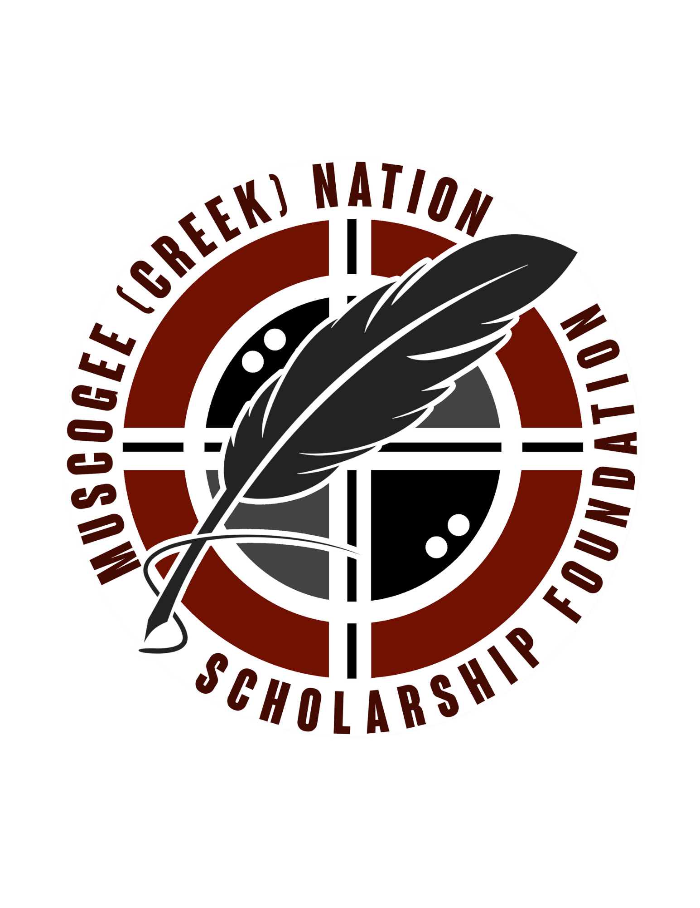

The Muscogee (Creek) Nation Scholarship Foundation
_____________________________________________________________________________________

Walter Dzurus III First Generation Scholarship

Scholarship Description
The Walter Dzurus III Scholarship is in honor of Mr. Walter Dzurus. Ms. Mildred S. Dzurus established the Scholarship in honor of her late son. The Scholarship is awarded for coursework from an accredited institution of higher education, technical school, or vocational trade school.

Amount of Scholarship Award $500

Purpose and Application of Funds
The purpose of this scholarship is to assist 1st generation students in their pursuit of post-secondary education.

Eligibility Guidelines
1. Must be an enrolled citizen of the Muscogee (Creek) Nation.
2. Must be a 1st generation student, attending an institution of higher education, technical school, or vocational trade school.
3. Must agree to authorize the Scholarship Foundation Program to publicize the scholarship award if selected.

