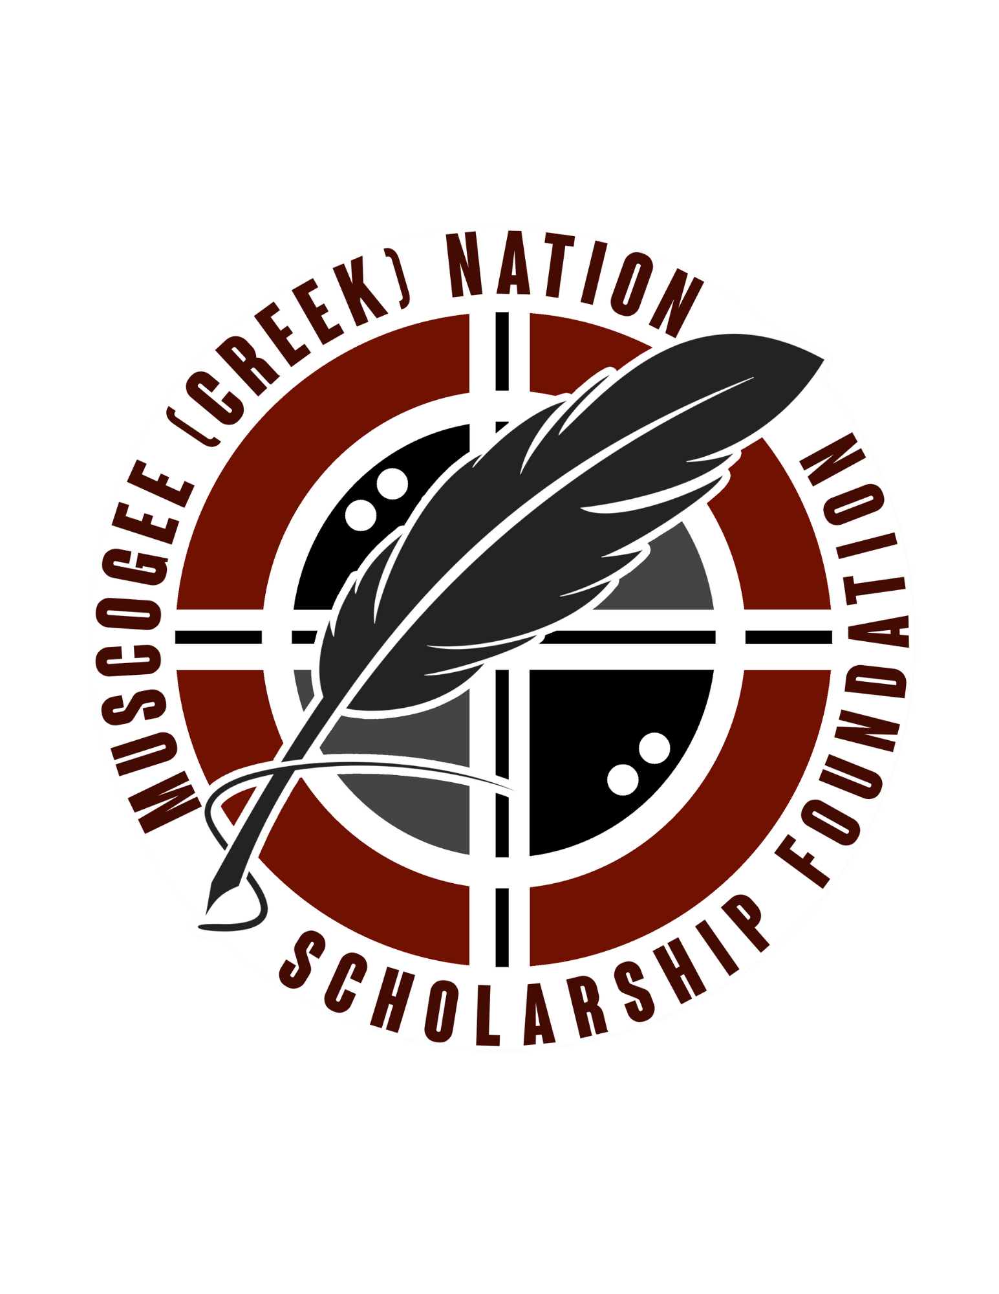

The Muscogee (Creek) Nation Scholarship Foundation
_____________________________________________________________________________________

Sterlin Harjo Scholarship

Scholarship Description
The Sterlin Harjo Scholarship, named after the Seminole/Muscogee filmmaker, will provide support to students who wish to pursue a career in film and television, arts, architectural & visual design or various creative professions.

Amount of Scholarship Award $1,000.00

Purpose and Application of Funds
The purpose of this scholarship is to financially aid students in their pursuit of post-secondary education and assist Muscogee Nation students majoring in creative professions.
This scholarship award can be utilized to pay for the cost of tuition, fees, books, tools, supplies, room and board, meals, testing or exam fees, transportation, or other incidental cost related to the cost of post-secondary education.
This scholarship is to be awarded to Muscogee Nation students who are attending an institution of higher education, technical or vocational trade school.

Eligibility Guidelines
1. Must be an enrolled citizen of the Muscogee (Creek) Nation.
2. Must be a freshman or sophomore, attending an institution of higher education, technical school, or vocational trade school.
3. Must be pursuing a degree in film and television, architectural & visual design, arts, or various creative professions.
4. Must have at least 3.0 GPA and ACT score of 22 or better.
3. Must agree to authorize the Scholarship Foundation Program to publicize the scholarship award if selected.

